1.Write a program to sort an array in ascending order.

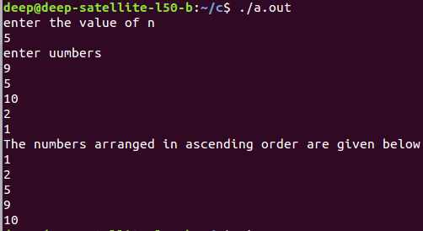

2.Write a program to sort an array in descending order.

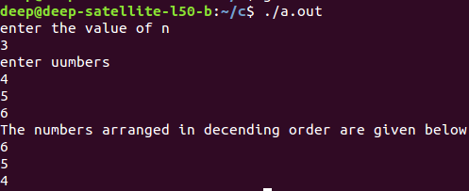

3.Write a program to search an element from an array.
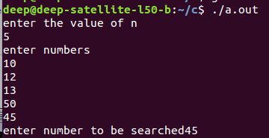

4.Write a program get the following outputs
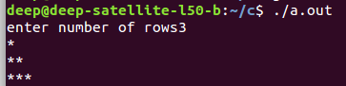
a.

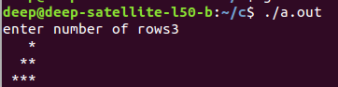
b.

c.

5. Write a program for the summation of the series
a. From 1 to n
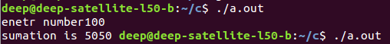

b. For all odd numbers

c. For all even numbers

6. Write a program to find the factorial of n.
Code:-
#include<stdio.h>
void main()
{
int n, i, fact=1;
printf("Enter the number");
scanf("%d",&n);
for(i=1; i<=n; i++)
{
fact= fact * i;
}
printf("Factorial is %d\n",fact);
}

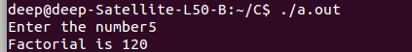

7. Write a program for the summation of the series with factorials
a. From 1 to n
b. For all odd numbers
c. For all even numbers
code:-
7.a:-#include<stdio.h>
void main()
{
int n, i, sum=0, fact=1;
printf("Enter the number");
scanf("%d",&n);
for(i=1; i<=n; i++)
{
fact= fact * i;
sum= sum + fact;
}
printf("Addition of factorial is %d\n",sum);
}
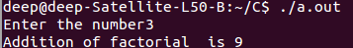

7.b:-
code:-
#include<stdio.h>
void main()
{
int n, i, sum=0, fact=1;
printf("Enter the number");
scanf("%d",&n);
for(i=1; i<=n; i++)
{
fact= fact * i;
if(i%2 != 0)
{

sum= sum + fact;

}
}
printf("Addition of odd factorial is %d\n",sum);
}
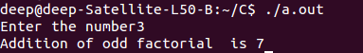

7.c:-
code:-
#include<stdio.h>
void main()
{
int n, i, sum=0, fact=1;
printf("Enter the number");
scanf("%d",&n);
for(i=1; i<=n; i++)
{
fact= fact * i;
if(i%2 == 0)
{

sum= sum + fact;

}
}
printf("Addition of even factorial is %d\n",sum);
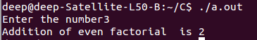
}

8. Write a program for
a. 1⁄2 + 2/3 + 3⁄4 + 5/6 + ....
code:-
#include <stdio.h>
float div(float n1)
{

return n1/(n1+1);
}
int main()
{
float n,sum=0;
scanf("%f",&n);
//printf("%d\n",fact(4));

for (int i = 1; i <= n; i++)
{

sum=sum+div(i);

}
printf("%f \n",sum );
return 0;
}
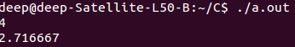

b. 1⁄2 + 3⁄4 + 5/6 + ....
code:-
#include <stdio.h>
static int a=1;
float div(float n1)
{
float ans=a;
a++;
ans=ans/a;
//printf("%f\n",ans );
a++;
return ans;

}
int main()
{
float n,sum=0;
scanf("%f",&n);
//printf("%f\n",div(1));

for (int i = 1; i <= n; i++)
{

sum=sum+div(i);
//printf("%f\n",d );

}
printf("%f \n",sum );
return 0;
}
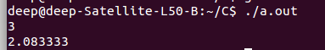

9. Write a program for addition, subtraction, multiplication and division of 2 numbers
code:-
#include<stdio.h>
void main()
{
int a, b, c, d, e, f;
printf("Enter the two numbers\n");
scanf("%d%d",&a,&b);
c = a + b;
d = a - b;
e = a * b;
f = a / b;
printf("Addition is %d\n",c);
printf("Subtraction is %d\n",d);
printf("Multiplication is %d\n",e);
printf("Division is %d\n",f);
}

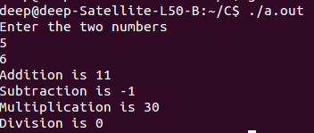

10. Write a program for multiplying 2 matrices [3x3]
code:-
#include <stdio.h>
int main(int argc, char const *argv[])
{
int a[3][3]={1,2,3,4,5,6,7,8,9},b[3][3]={8,2,4,7,8,9,5,4,2},c[3][3];
int sum=0;
printf("matrix a:\n");
for (int i = 0; i < 3; i++)
{
for (int j = 0; j < 3; j++)
{
/* code */
printf("%d ",a[i][j] );
}
printf("\n");
/* code */
}
printf("\nmatrix b\n");
for (int i = 0; i < 3; i++)
{
for (int j = 0; j < 3; j++)
{
/* code */
printf("%d ",b[i][j] );
}
printf("\n");
/* code */
}
printf("\n");
for (int i = 0; i <= 2; i++) {
for (int j = 0; j <= 2; j++) {
sum = 0;
for (int k = 0; k <= 2; k++) {
sum = sum + a[i][k] * b[k][j];
}
c[i][j] = sum;
}
}

printf("\nresultant metrix:\n");
for (int i = 0; i < 3; i++)
{
for (int j = 0; j < 3; j++)
{
/* code */
printf("%d ",c[i][j] );
}
printf("\n");
/* code */
}
return 0;
}

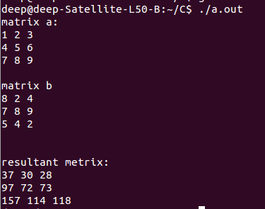

11. Write a program to display the Fibonacci series for n
code:-
#include<stdio.h>
void main()
{
int a, i, b=0, c=1, sum=0;
printf("Enter the number\n");
scanf("%d",&a);
for(i=0; i<=a; i++)
{
sum= b + c;
b=c;
c=sum;
printf("%d ",sum);
}
printf("\n");
}

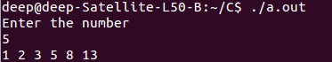

12. Write a program to find the given number is prime or not.
Code:-
#include <stdio.h>
int main()
{
int n, i, f=0;
printf("Enter the number ");
scanf("%d",&n);
for(i=2; i<=n/2; i++)
{
if(n%i==0)
{
f=1;
break;
}
}
if (f==0)
printf("%d is a prime number\n",n);
else
printf("%d is not a prime number\n",n);
}

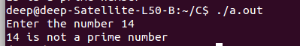

13. Write a program to find the transpose of a matrix
code:-
#include <stdio.h>
int main(int argc, char const *argv[])
{
int a[3][3]={2,3,1,4,5,6,7,8,9},b[3][3];
int temp;
for (int i = 0; i < 3; ++i)
{
/* code */
for (int j = 0; j < 3; j++)
{
printf("%d ", a[i][j]);
b[j][i]=a[i][j];
}
printf("\n");
}
printf("\n");
for (int i = 0; i < 3; ++i)
{
/* code */
for (int j = 0; j < 3; j++)
{
printf("%d ",b[i][j]);
}
printf("\n");
}

return 0;
}
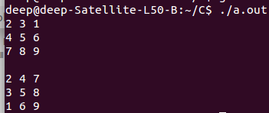

14. Write a program to generate a reverse output. E.g.:- Hello ←→ olleH
code:-
#include <stdio.h>
#include <stdlib.h>
int main(int argc, char const *argv[])
{
char a[100]={"hello"};
printf("%s\n",a );
scanf("%s",a);
for (int i = 99; i >= 0; i--)
{
int a1=a[i];
if (a1!=0)
{
printf("%c",a[i] );
/* code */
}
}
//printf("%d\n",l );
return 0;
}
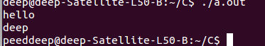

15. Write a program to find for given number is palindrome or not.
Code:-
#include<stdio.h>
void main()
{
int a, b, c=0, n;
printf("Enter the number\n");
scanf("%d",&n);
a=n;
while (a >0)
{
b=a%10;
c=(c*10)+b;
a= a/10;
}
if(n == c)
printf("%d is palindrome\n",n);
else
printf("%d is not Palindrome\n",n);
}
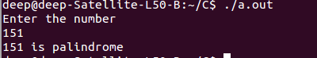

16. Write a program to concatenate two strings
code:-
#include<stdio.h>
#include<string.h>
void main()
{
char str1[12];
char str2[12];
printf("Enter the string");
scanf("%s%s",str1,str2);
strcat(str1,str2);
printf("final string is %s\n",str1);
}
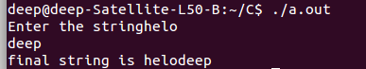

17. Write a program to find the length of the given string
code:-
#include<stdio.h>
#include<string.h>
void main()
{
char str1[12];
int l;
printf("Enter the string");
scanf("%s",str1);
l=strlen(str1);
printf("Length of string is %d\n",l);
}
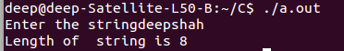

18. Write a program to convert the given Upper case input into the Lower case.
Code-
#include <stdio.h>
int main(int argc, char const *argv[])
{
char s1[100],s2[100];
printf("enter string to conver into lower case:\n");
scanf("%s",s1);
int i,j=0;
for(i = 0; s1[i] != '\0'; i++,j++);
{}
for (int i = 0; i < j; ++i)
{
s1[i]=s1[i]+32;
}

printf("concatinated string:%s\n", s1);
return 0;
}
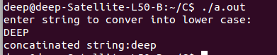

19. Write a program to convert the given Lower case input into the Upper case
code:-
#include <stdio.h>
int main(int argc, char const *argv[])
{
char s1[100],s2[100];
printf("enter string to convert into upper case:\n");
scanf("%s",s1);
int i,j=0;
for(i = 0; s1[i] != '\0'; i++,j++);
{}
for (int i = 0; i < j; ++i)
{
s1[i]=s1[i]-32;
}

printf("concatinated string:%s\n", s1);
return 0;
}
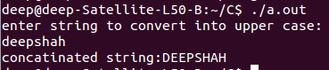

20. Write a program to find given number is leap year or not.
Code:-
#include<stdio.h>
void main()
{
int a;
printf("Enter the year\n");
scanf("%d",&a);
if (a%4 == 0)
printf("%d year is a leap year\n",a);
else
printf("%d year is not a leap year\n",a);
}
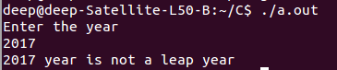

21. Write a program to print Floyd triangle
1
23
456
code:-
#include<stdio.h>
void main()
{
int i, j, n, a=1;
printf("Enter the number");
scanf("%d",&n);
for(i=0; i<=n; i++)
{
for(j=1; j<=i; j++)
{
printf("%d",a);
a++;
}
printf("\n");
}
}
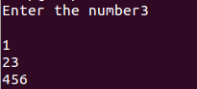

22. Write a program to print
1
01
010
1010
10101
code:-
#include <stdio.h>
int main()
{
int k=1;
int n=6;
for (int i = 0; i <= n; ++i)
{
/* code */
for (int j = 0; j <= n; ++j)
{
/* code */
if(i>j)
{
k++;
if(k%2==0)
printf("1");
else
printf("0");
}

}
printf("\n");
}
return 0;
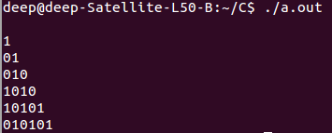
}

23. Write a program to find the H.C.F and L.C.M.
code:-
#include <stdio.h>

int getGcd(int a, int b);
int main(){
int num1, num2, gcd, lcm;
printf("Enter two numbers\n");
scanf("%d %d", &num1, &num2);
gcd = getGcd(num1, num2);
lcm = (num1 * num2)/ gcd;
printf("GCD of %d and %d is %d\n", num1, num2, gcd);
printf("LCM of %d and %d is %d\n", num1, num2, lcm);

return 0;
}
int getGcd(int a, int b) {
if (b == 0) {
return a;
}
else {
return getGcd(b, a % b);
}

}

